Hermes Transport
Courier Services Management and Tracking Platform

Installation Guide


Table of contents
Intro 3
Prerequisite Programs and Software 3
Links to software 4
Configure PHP 24
Cloning the Project 26
Install Dependencies 28
Configure the Environment 28
Build and seed the database 28
Start the App 29

Intro
This document will guide you through the steps needed to install all the prerequisite programs and software needed for the Hermes Platform System as well as how to configure them for the initial setup and how to access the system. This document is to be used in tandem with the Herms Platform User Guide which shows you how to navigate through the system once it has been installed. This guide makes the assumption you are going to install and run this system on a Windows 11 machine.

Prerequisite Programs and Software
In the table below you will find a list of all software and programs needed to install the Hermes Platform system

Tool | Version | Notes
PHP | 8.2 recommended | The project was built and tested on 8.2.
Composer | Latest | Windows: use the Composer-Setup.exe installer from getcomposer.org.
Node.js + npm | 18 or higher | npm installs with Node.js program
Git | Latest | Used to run commands for the system
Xxamp | Latest
Visual Code | Latest | Used to view and edit other software

Links to software
For all programs the default options for all the installers will be correct, this next sections provides links to all the software so you my download them and has a visual guide for each of the installers

Xxamp: Xxamp Download

When clicking on the link you will be taken to Xxamp’s webpage where you will be able to download and install Xxamp. Find the table with your operating system. Once found, look for the latest version and click the download button in its row.
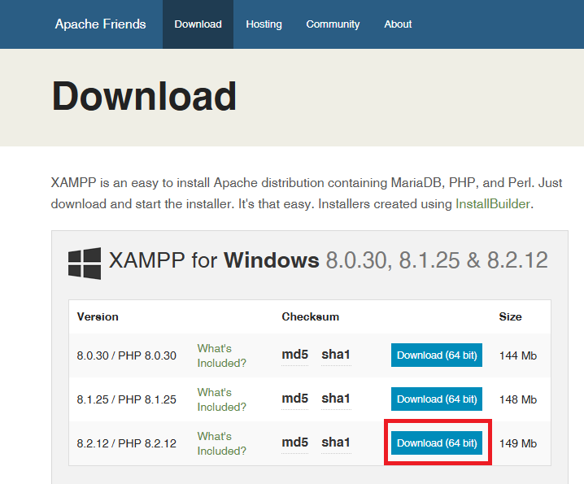
Once downloaded execute the installer and follow the pictures below, click on next in the bottom right
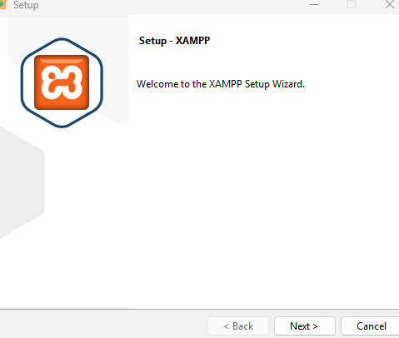
Next leave everything on the right side as the default with everything selected and then click next at the bottom right
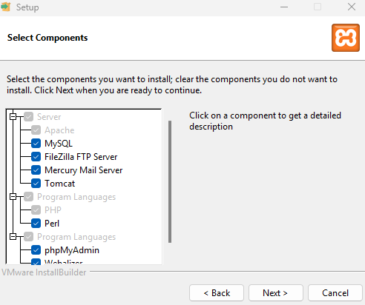
On the next page you will select a folder for where Xxamp will be installed, click next after you have selected the chosen folder
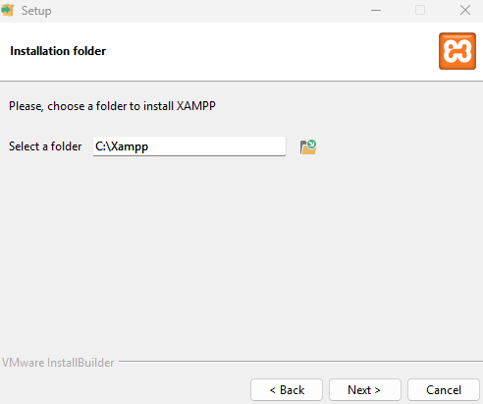
The program will now install, Once it has completed, click on the finish button

PHP: PHP Download

When clicking on the link you will be taken to the PHP download page, please configure at the top of the page what operating system you are using, please select ZIP downloads and Default PHP. These should be the default options but verify that the choices are correct, (refer to the picture below for guidance)
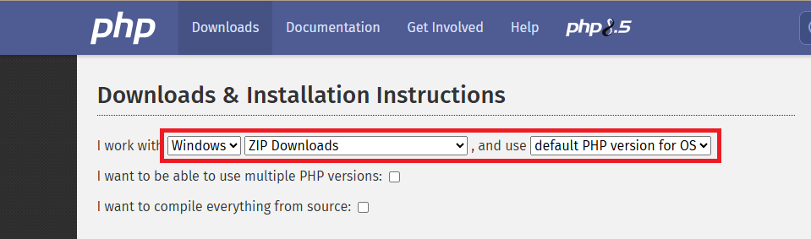
Once configured scroll down the webpage until you reach the PHP version number and then click on the source code link only
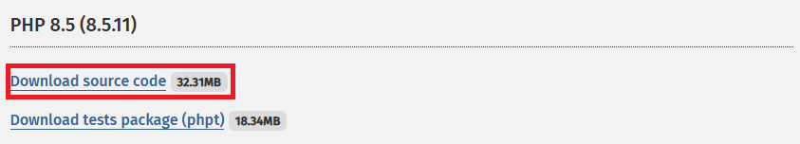

Once downloaded, extract the files to anywhere on your computer, You have finished installing PHP

Composer: Composer download

This link will drop on composer’s webpage, please click on the Composer-setup.exe to download it and then execute it once you have downloaded it.
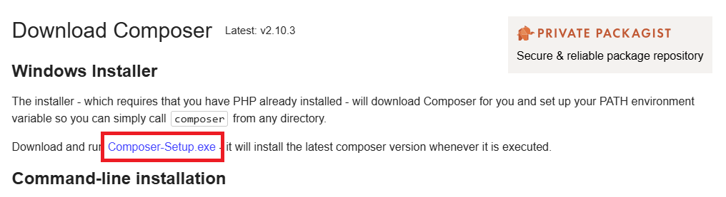
After you have downloaded the file, execute it and select either install for all or install for me only, this guide picked install for me only
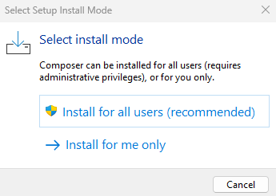
On the next page, click next. Do not tick the check box for developer mode
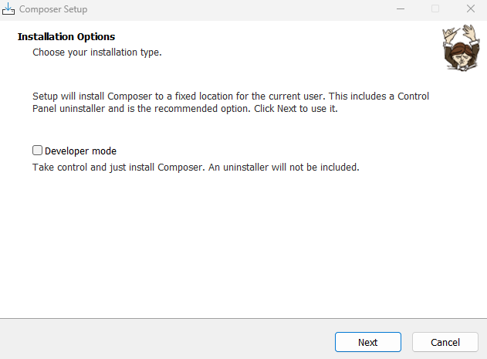
On the next page the default folder selected should be your Xxamp PHP file. Make sure that it is and then click next at the bottom right of the page
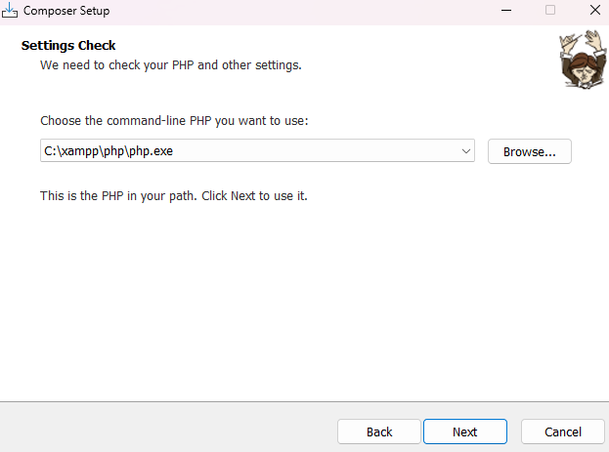
Composer is now being installed, Once completed, click on the finish button

Node.js : Node js Download

Once you click on the link above you will be taken to Node.js webpage, scroll down to the section where you can get a prebuilt installer, select your operating system and architecture
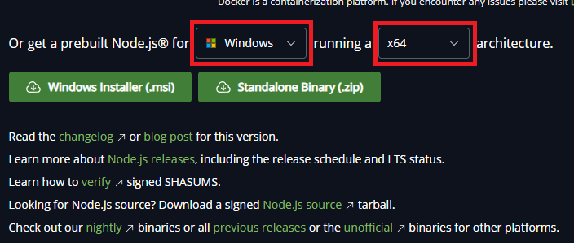
Afterwards click on the installer button for your OS and not the standalone Binary
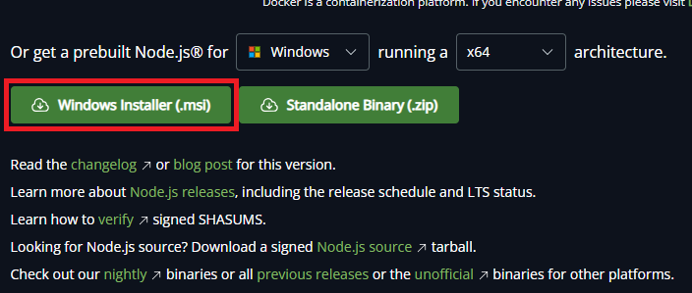

Once you have downloaded the installer, execute it and then click next
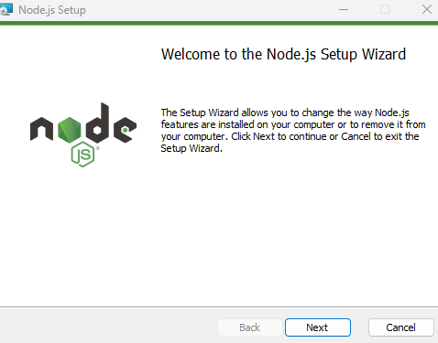

Click on the check box to accept the license Agreement and then click on the next button
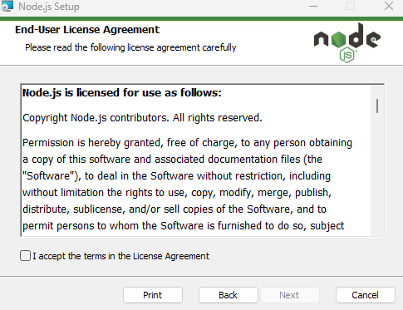
Next you must choose which folder node must be installed into. Click on next once you have selected
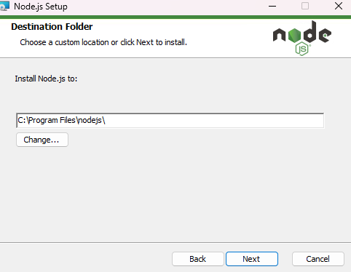

Next leave all the default options and click on next
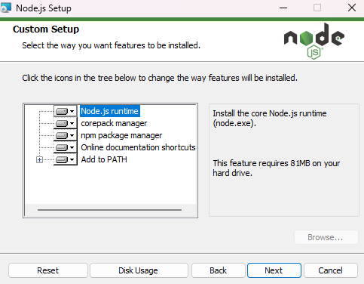
Do not click on the check box and immediately click on the next button, you do not need to C/C++ npm
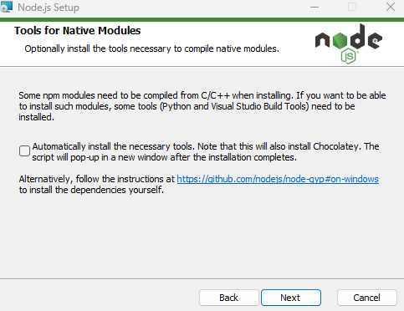
The program will now install and once complete click on the finish button

Git: Git Download

Once you click on the link above you will be taken to git’s website to download the software, select from the top section your operating system.
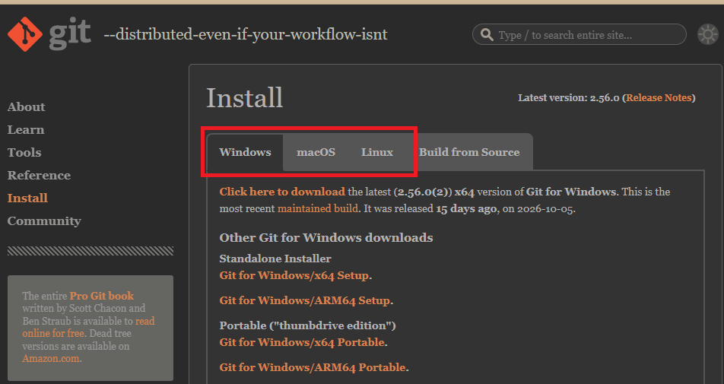
Once selected click on the git for windows/x64 Setup
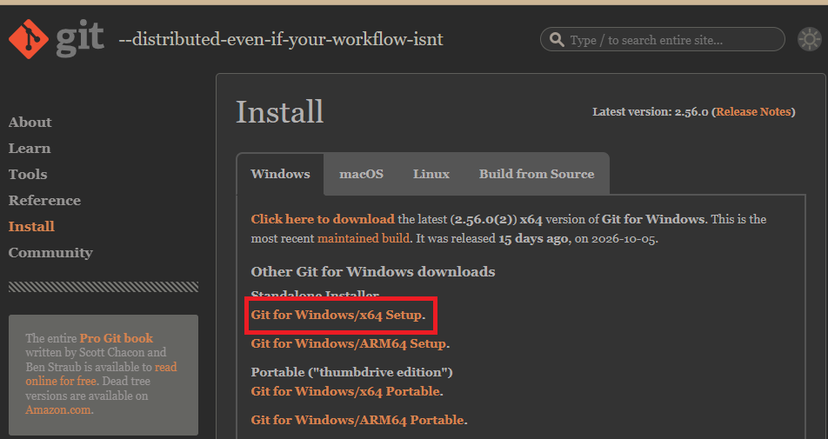

Once you have downloaded the installer, execute it and click on the next button

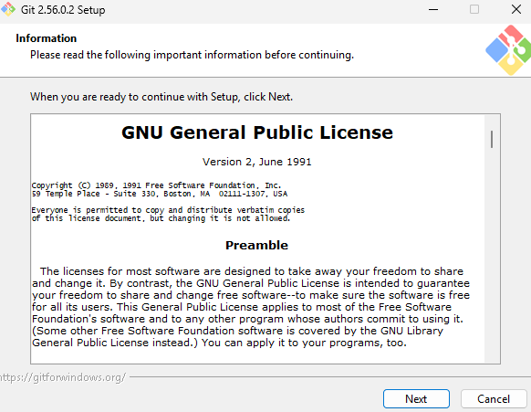
Next you will choose the location where you would prefer the git files to be installed to. Once selected click on the next button
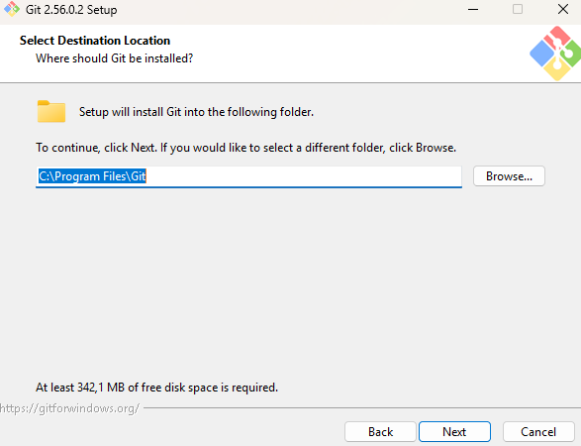
In the next page you will select which components should be installed, the default ones can be chosen
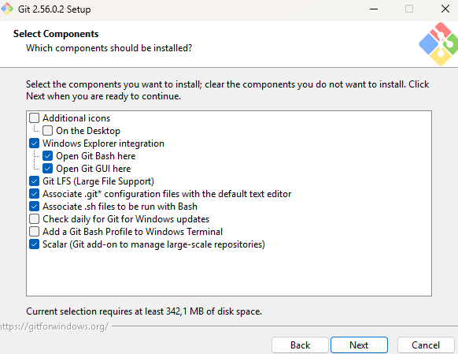
On the next page you can choose whether or not the system creates a shortcut for you. Tick the box if you don't want it to add one and then click next or just click next if you would like one
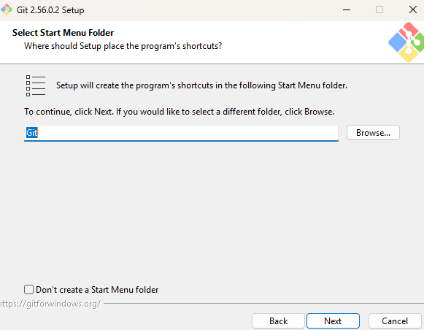
Next you will choose the text editor, the default one works without issues
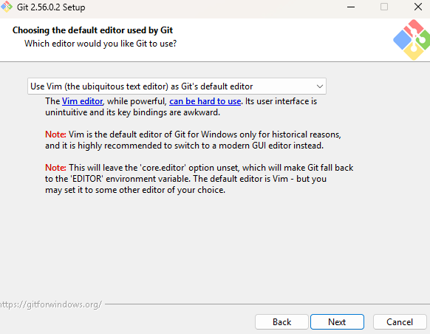
Next you will choose a default name for that git will assign to repositories that you create, the default choice is correct. Click next once you have decided
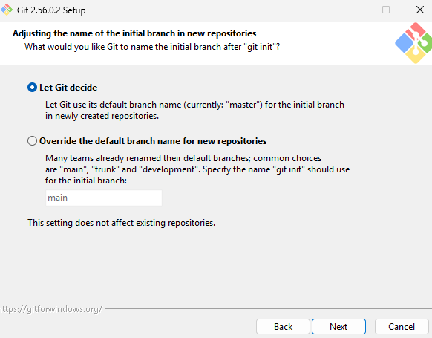
Next we choose the recommended option and click next
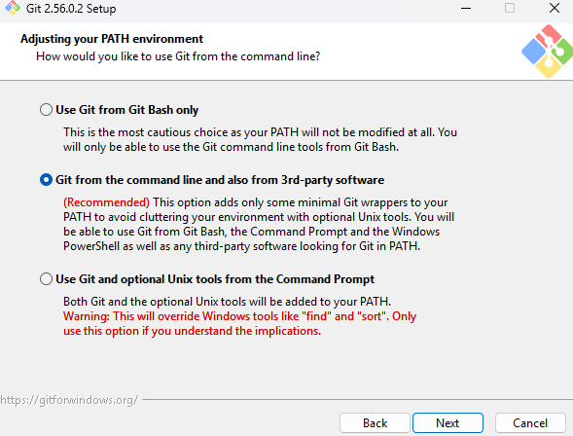
In the next page we will choose the bundled SSH executable and click next
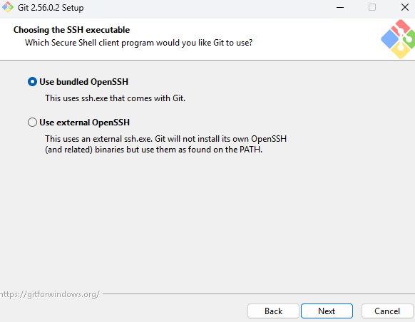
Next we choose use native windows secure channel library
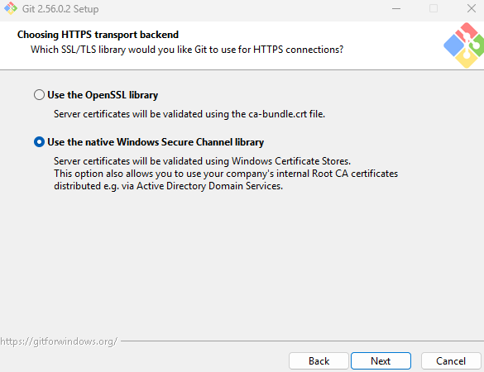

Next we choose the line ending we prefer for git to read
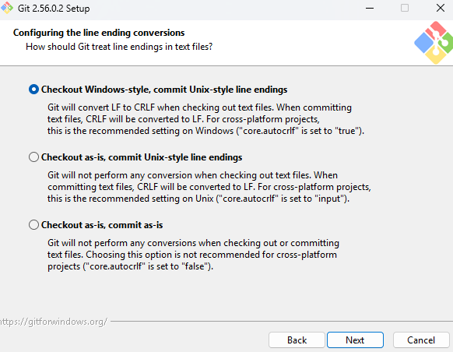
We now choose preferred terminal emulator
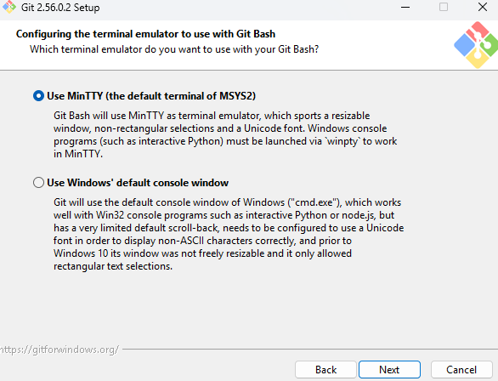

We now select how git operates the git pull command
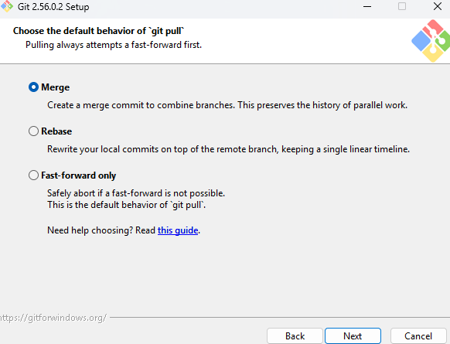
We now select help with credential manager
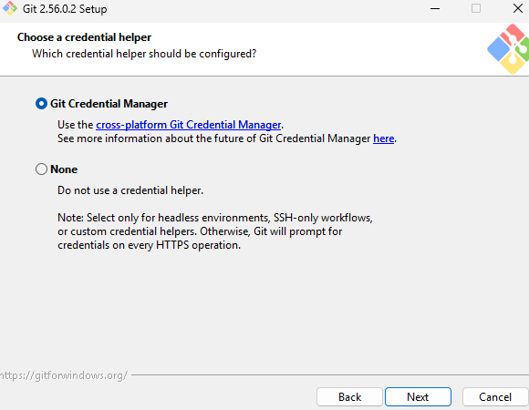
WE enable file system caching and then click the install button, once the system has completed its installation you can click finish
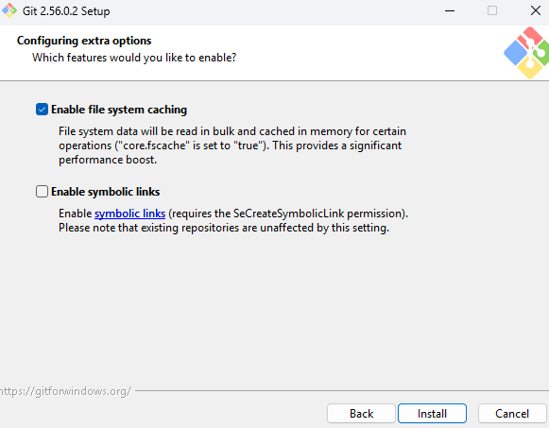

Visual Code: Visual Download

Once you have clicked on the above link, click on the download button for your devices operating system
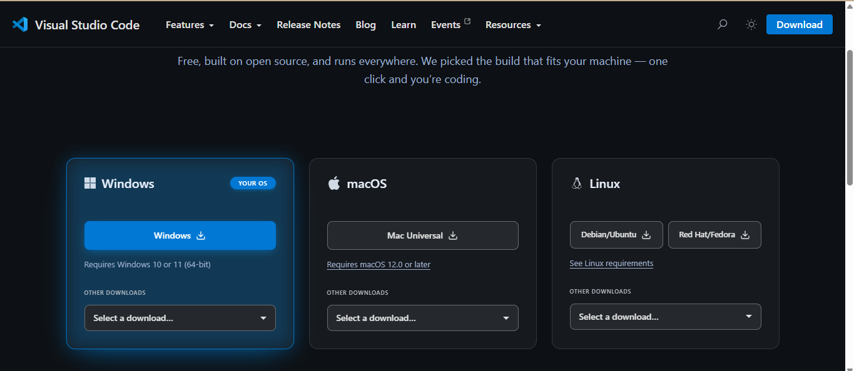

Once you have downloaded the installer, execute it, accept the license agreement and click on next
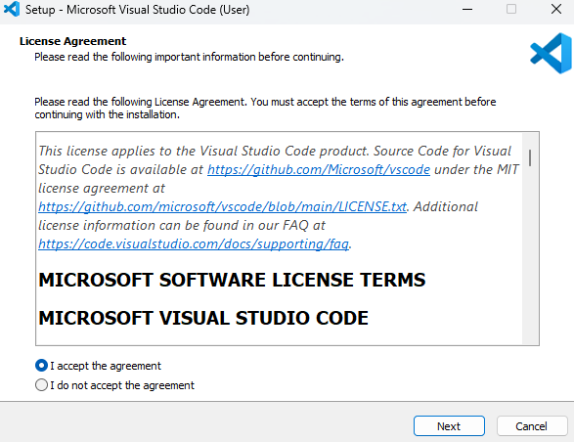
Next you will choose where to install the app, click on next once you have chosen a location
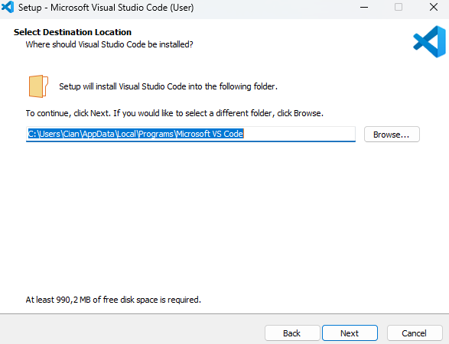
Choose if the app will add an icon to the start menu, tick the check box if you do not want it to and click on next
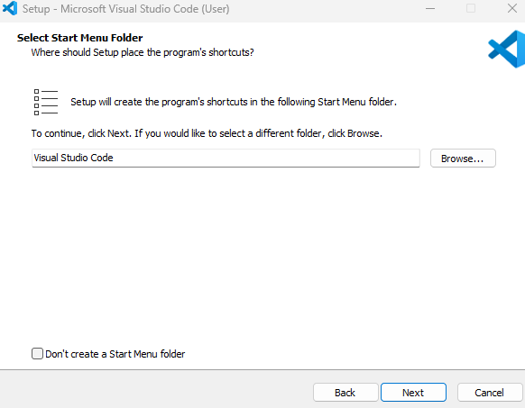
Configure the additional tasks visual studio code must perform, the default ones are the only ones needed.
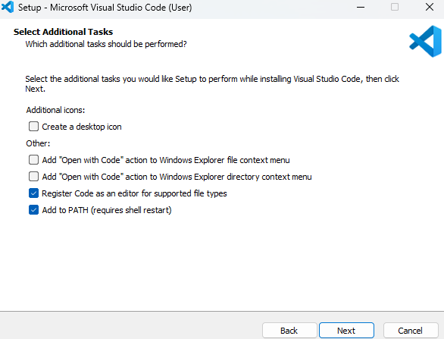
Click the install button and wait for the application to complete its installation

Configure PHP
Before the system can be installed, you must configure the php.ini file to do this navigate to this->”The drive you installed all of the software on”-> then click on your Xxamp folder. In this case we installed all the software on the C: drive
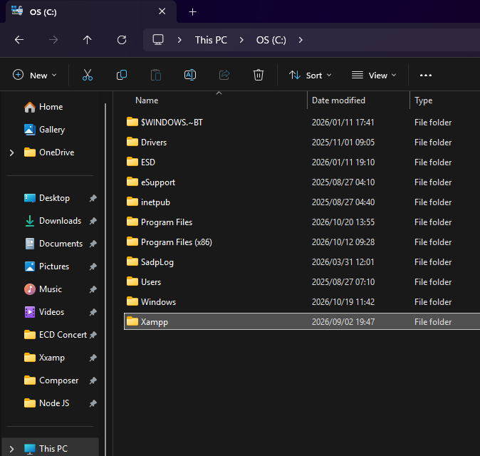
Inside this folder find a folder called php
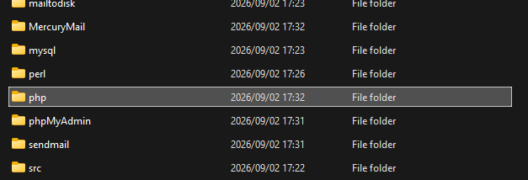
In this folder find the file named php with the ini source file extension
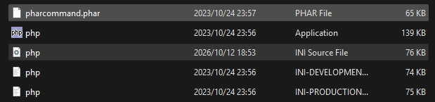
Right click on this file and open it with visual studio code

Once open in visual studio code, press control+f to open the search tool and then you will search for the following lines of codes and remove the semi-colon from the front of the line. The first line will have pictures to guide you.

extension=fileinfo

Copy the above text into the box created by ctrl+f
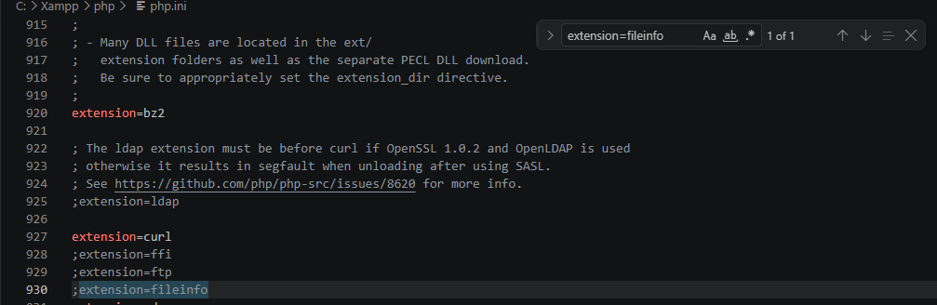
Some of the extensions will already have their semi-colon removed, if they haven't, remove the semi-colon and you will see that the piece of code now is no longer greyed out. You do the same for the rest of the extensions

extension=pdo_sqlite
extension=sqlite3
extension=gd
extension=mbstring
extension=openssl
extension=curl
extension=zip

Once you have completed all the extensions you must then save the file before closing it

Cloning the Project
Navigate through your file explorer and locate where you would prefer to install the project, in this example we have installed it within document. Once you have found the location, create a folder and name the it Hermes platform
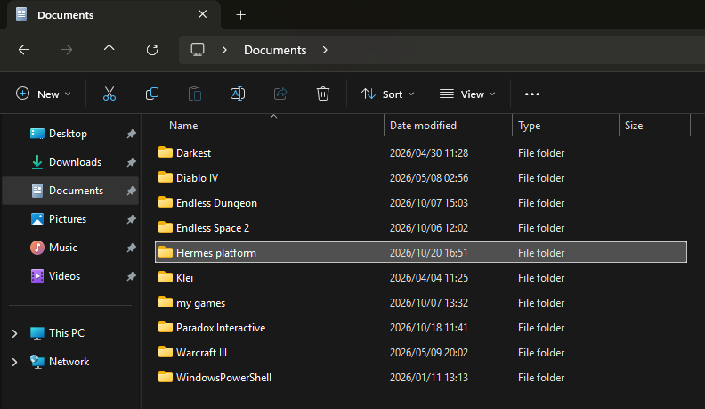
Enter the empty folder right click on the screen witch will bring up a menu and click on open gitbash here
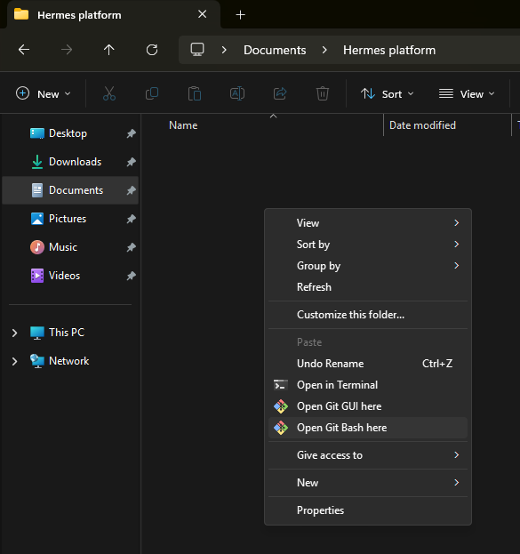
This will now open a new form that looks similar to a command prompt, from within this command prompt execute the following commands one after the other
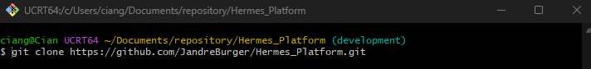
Then execute the command
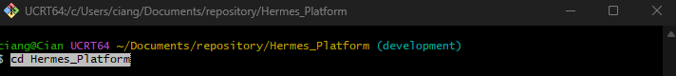
The execute the command
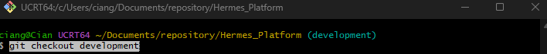

Once you have executed all the commands the Hermes Platform folder will not be filled with files
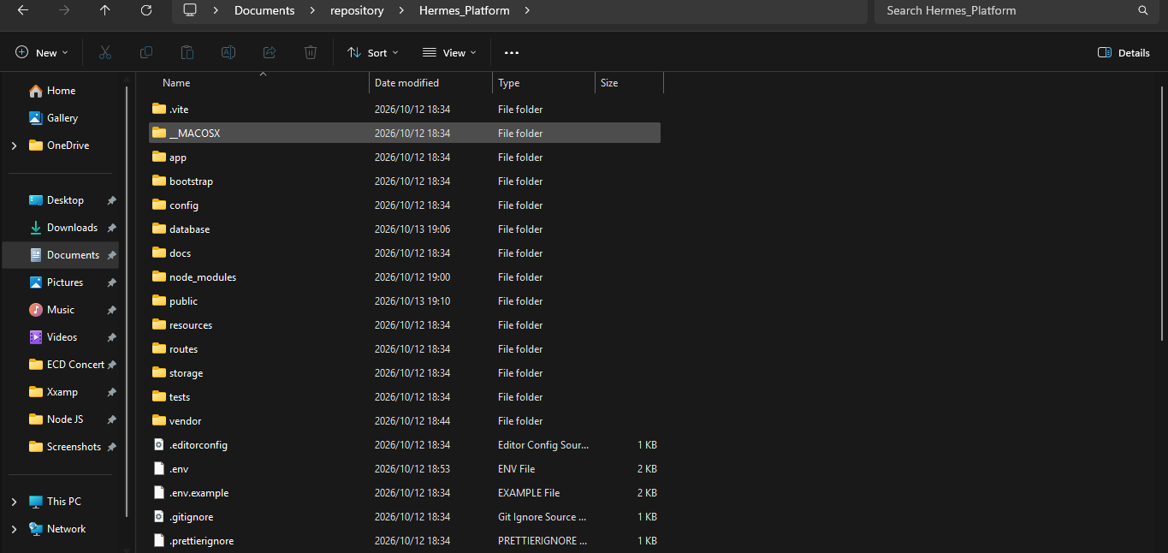

Install Dependencies
Once the folder has been filled, run this command to connect composer
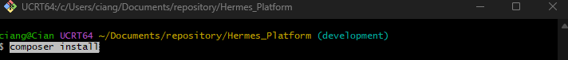
Afterwards run this command to connect node.js and npm
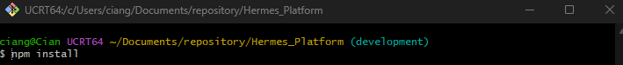

Configure the Environment
Run the following three commands
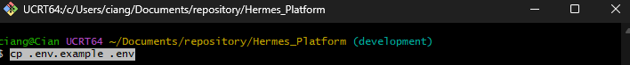
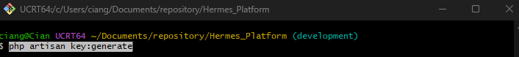

Build and seed the database
To seed the database with dummy data for testing purposes use the following command
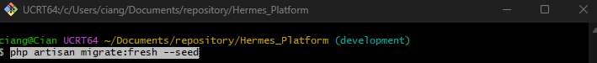

Start the App
You have now completed all the steps for installing and setting up the Hermes Platform system. To access the system you must now run two terminals simultaneously. You must navigate back to the Hermes Platform folder and right click to open two separate git bash
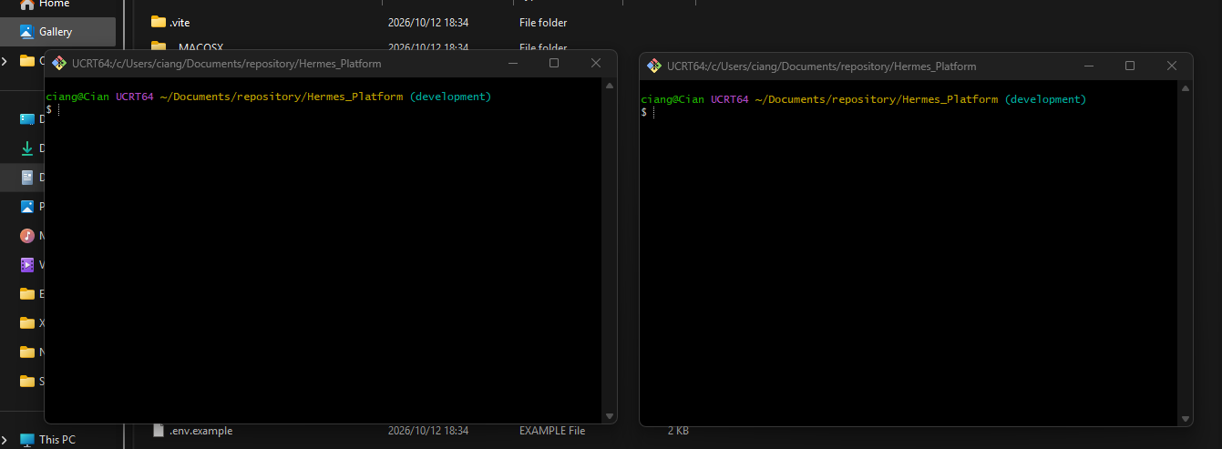
In the first terminal you must execute the command
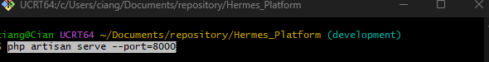
In the second terminal you must execute the command
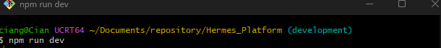
In your second terminal you should now be looking at the image below
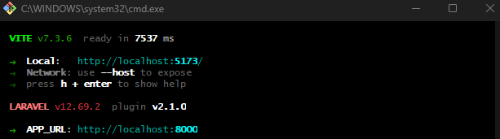
In your first terminal you should now see
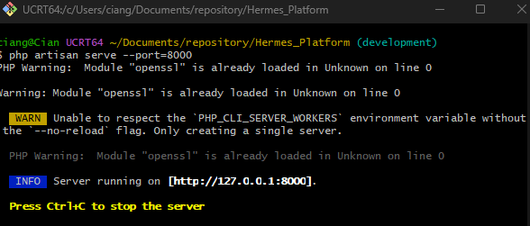
In your first terminal you will now be able to copy an IP address
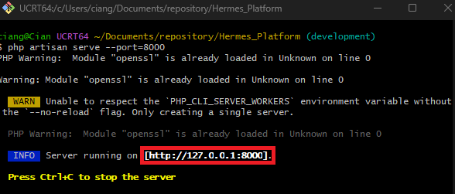
Your final step is to highlight the IP address and right click and then click copy, do not use short cuts and Ctrl+C will stop the program. From this point you may now use the User Guide.

